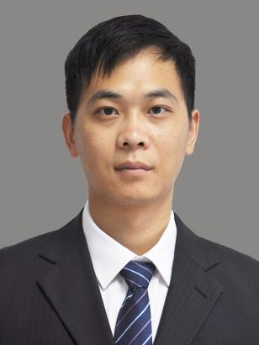

**Zeng Wenfang**

Professor

Ph.D. Supervisor

Innovation Team of Cultivation Physiology and Techniques of Drupe Fruit Trees, ZFRI, CAAS

**Contact**

Email: [zengwenfang@caas.cn](mailto:zengwenfang@caas.cn)

**Research interests**

Fruit developmental mechanism and molecular breeding of peach