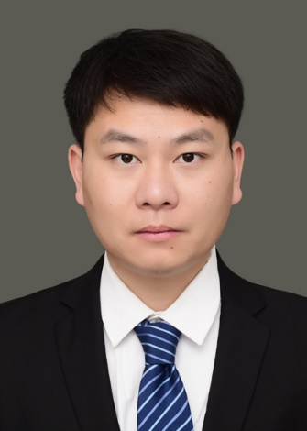

**Sun Shihang**

Assistant Professor

Innovation Team of Cultivation Physiology and Techniques of Drupe Fruit Trees, ZFRI, CAAS

**Contact**

Email: [sunshihang@caas.cn](mailto:sunshihang@caas.cn)

**Research Interests**

Molecular mechanism of peach rootstock resistance