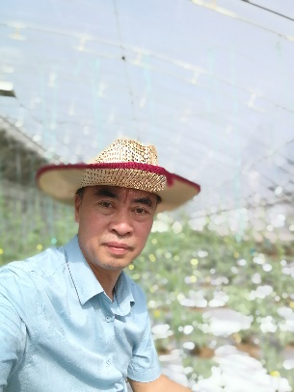 **Gu Qinsheng**

Professor

Ph.D. Supervisor

**Innovation Team of Monitoring and Control Technology of Fruit Quality and Safety, ZFRI, CAAS**

## Research Interests:

* Epidemic and Transmission of Viruses in Cucurbits
* Control of Virus Diseases in Cucurbits

## Contact:

**Phone:** 86–371–65330997 **E-mail:** [guqinsheng@caas.cn](mailto:guqinsheng@caas.cn)

**Add:** South end of Weilai Road, Guanchenghuizu District, Zhengzhou, China

## Selected Publications

**Argonaute 1 and 5 proteins play crucial roles in the defence against cucumber green mottle mosaic virus in watermelon**

Molecular Plant Pathology

2023|Journal Article

DOI: [10.1111/mpp.13344](http://dx.doi.org/10.1111/mpp.13344)

***Colletotrichum* Species Associated with Anthracnose Disease of Watermelon (*Citrullus lanatus*) in China**

Journal of Fungi

2022|Journal Article

DOI:10.3390/jof8080790

**AC5 protein encoded by squash leaf curl China virus is an RNA silencing suppressor and a virulence determinant**

Frontiers of Microbiology

2022|Journal Article

DOI: 10.3389/fmicb.2022.980147

**Construction of an Agrobacterium-mediated infectious cDNA clone of melon aphid-borne yellows virus**

Virus Research

2022|Journal Article

DOI:10.1016/j.virusres.2022.198779

**Development of Bottle Gourd Lines Resistant to Zucchini Yellow Mosaic Virus using Ethyl Methanesulfonate Mutagenesis**

HortScience

2021|Journal Article

[DOI:10.21273/HORTSCI15898-21](https://doi.org/10.21273/HORTSCI15898-21)

**Interspecific recombination between Zucchini tigre mosaic virus and 2 Papaya ringspot virus infecting cucurbits in China**

Frontiers in microbiology

2021|Journal Article

DOI:10.3389/fmicb.2021.773992

**A cucumber green mottle mosaic virus vector for virus‑induced gene silencing in cucurbit plants**

Plant Methods

2020|Journal Article

[DOI:10.1186/s13007-020-0560-3](https://doi.org/10.1186/s13007-020-0560-3)

**Expression and Localization Patterns of a Small Heat Shock Protein that Interacts with the Helicase Domain of Cucumber Green Mottle Mosaic Virus**

Phytopathology

2019|Journal Article

DOI:10.1094/PHYTO-11-18-0436-R