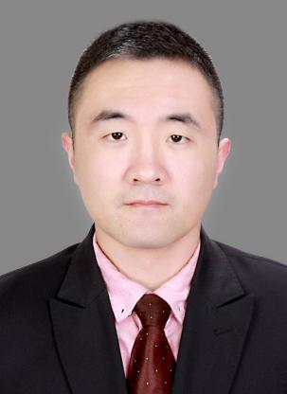

**Si Peng**

Associate Professor

1. sc Supervisor

Innovation Team of Cultivation Physiology and Techniques of Drupe Fruit Trees, ZFRI, CAAS

**Contact**

Email: [sipeng@caas.cn](mailto:sipeng@caas.cn)

**Research interests**

Research and application of fruit tree nutrient management model