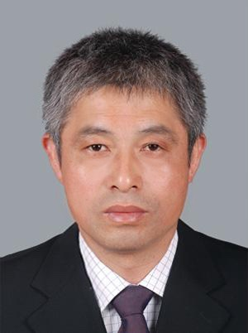

## Liu Chonghuai

Professor

Ph.D. Supervisor

Innovation Team of Grape Genetic Resources and Breeding. ZFRI.CAAS

**Contact**

* Email:liuchonghuai@caas.cn
* Tel:86-371-65330966
* Add:

Zhengzhu fruit research insititute ,Hanghai Donglu, Guancheng District, Zhengzhou,Henan,China

**Research Interests**

Grape Resources Collection and Preservation  
Grape Beeding

Grape Cultivation Technology

## Selected Publications

### Endophytic bacterium pseudomonas fluorescens RG11 may transform tryptophan to melatonin and promote endogenous melatonin levels in the roots of four grape cultivars

Frontiers in Plant Science

2017|Journal Article

DOI:[10.3389/fpls.2016.02068](http://dx.doi.org/10.3389/fpls.2016.02068)

### Integrating Omics and Alternative Splicing Reveals Insights into Grape Response to High Temperature endogenous melatonin in their hosts.

Plant Physiology

2017|Journal Article

[DOI:10.1104/pp.16.01305](https://doi.org/10.1104/pp.16.01305)

### Genome Assembly and Transcriptome Analysis of the Fungus Coniella diplodiella During Infection on Grapevine (Vitis vinifera L.)

Frontier in microbiology

2020|Journal Article

[DOI:10.3389/fmicb.2020.599150](https://doi.org/10.1104/pp.16.01305)

### New quantitative trait locus (QTLs) and candidate genes associated with the grape berry color trait identified based on a high-density genetic map

BMC Plant Biology

2020|Journal Article

DOI: 10.1186/s12870-020-02517-x

### Transcriptome analysis reveal the putative genes involved in light-induced anthocyanin accumulation in grape ‘Red Globe’ (V. vinifera L.)

Gene

2020| Journal Article  
DOI: 10.1016/j.gene.2019.144284

## Events

no