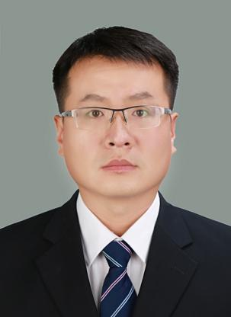

**Pan Lei**

Associate Professor

1. sc Supervisor

Innovation Team of Cultivation Physiology and Techniques of Drupe Fruit Trees, ZFRI, CAAS

**Contact**

Email: panley@126.com

**Research interests**

Resistance breeding and cultivation physiology of peach