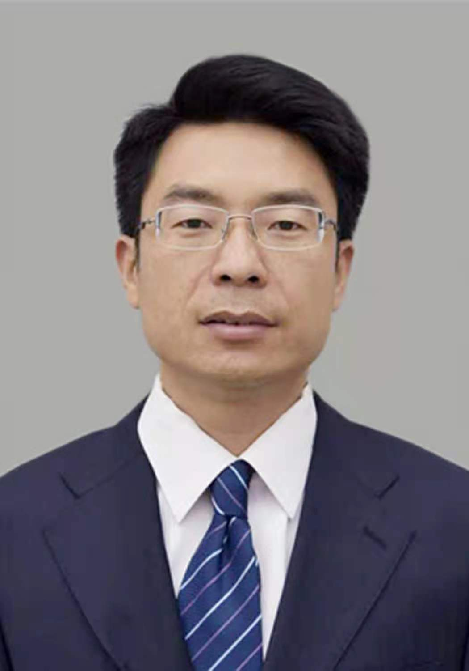

**Gao Dengtao**

Associate Professor

1. sc Supervisor

Innovation Team of Cultivation Physiology and Techniques of Drupe Fruit Trees, ZFRI, CAAS

**Contact**

Email: [gaodengtao@caas.cn](mailto:gaodengtao@caas.cn)

**Research interests**

Simplified and efficient cultivation model study