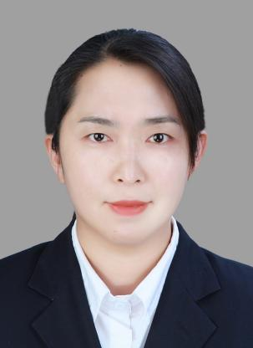

**Liu Congli**

Associate Professor

1. sc Supervisor

Innovation Team of Cultivation Physiology and Techniques of Drupe Fruit Trees, ZFRI, CAAS

**Contact**

Email: [liucongli@caas.cn](mailto:liucongli@caas.cn)

**Research interests**

Germplasm and breeding of cherry